MI Report: Mike Long
Mike Long
There is something a little bit different about the Invitational. For American players who are new to the pro-game, even in the last three or four years, there was never a time when making the U.S. National team wasn't equal or better in cash prizes, to making Top 4 in at a Pro Tour. Before U.S. Nationals was transformed into a money tournament, it was the last of the great amateur events. You played your heart out, round after round, for the distinction of being seen by yourself and your peers at the top of the game. Almost like an insane Regional Championship, Nationals was dominated by the great players of past and present, Mark Justice, Henry Stern, Jon Finkel, Bob Maher, Matt Place, even me, Mike Long, and they played for the game. There were some nice fringe benefits, a free trip to Worlds, maybe even some Sideboard coverage, but that was about it.
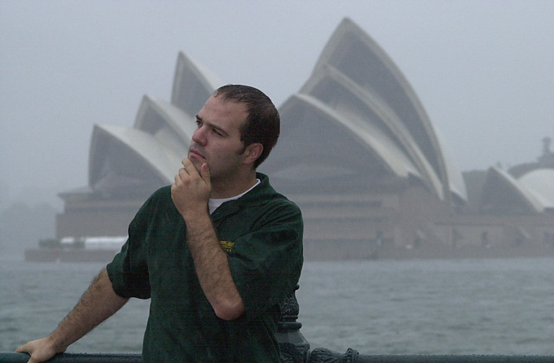
The Invitational never changed. The top sixteen players of the world are invited to an exotic location to bash one another, for nothing but a plaque and the honor of making a card (which actually usually doesn't really even cross your screen until the whole thing is over and done with). Players attending always bring their 'A' game. Where else might Chris Pikula be the top player in the world and he drop all other pretence and play, seeking only victory? Not to win money, boxes. Just to win. Where else could you be the best player in the world, but when Wizards of the Coast lines up the best players in the world and you get your fair shot at all of them.
I want everyone to get the feel of the Invitational. Of the selection process, hoping that your break through season was enough to get you in because plenty of great players with fine seasons have missed the cut. Take Mark Lepine who made a PT Top 4 and then the finals of the World Championship to sit back home in New Hampshire and download net coverage of the Invitational as it visited Kuala Lumpur. Ben Rubin made the trip to two pro Finals in his rookie season, but didn't get a trip to Barcelona. He had to wait until this year when semifinal performances in London and New York finally convinced the Magic world he was worthy of a trip to Sydney where, incidentally, he almost walked with the whole thing.
I want you to have the feeling of the trip. A killer long flight, wondering how everyone is going to act. Will they share info or will people look over their shoulders? Will everyone go out and party, or stay at the home hotel and draft and test the nights away? And when it was time to play, when it was time to win, then what would that feel like?
If your last year had been your lucky year, what would you have seen in Sydney? Would you have been an insider whose peers finally recognized their effort, like Rubin or Ryan Fuller? What if you were a unknown quantity like Alex Shvartsman? Or were having a breakaway season like Trevor Blackwell or Bob Maher Jr.? Or maybe this isn't your first time around the block, but you still want to prove that you can still hang with the big dogs, like Kai Budde, Dave Price or even Jon Finkel?
If this was your first time, your friends might have made sure they got to have an extra night the week before you left to hang out with you, bask in your glow. They would ask you what you would play, and tease that you might win a game or two, if not a match. If it was your second time you might have wondered what went wrong the first time, when you got caught the first few rounds daydreaming, and you might determine to double your efforts this time. What if you were this close last time, missed the finals on tie-breakers, like Zvi in Kuala Lumpur, or even worse, what if you made it all the way only to be turned away in the fifth match of the finals, like Finkel? What if you've done it all, you're the best in Magic, except...
This year, like every other year, all sixteen of us fell into one of these categories. Where was I? I was walking around with Trevor ('T-Bone' as he was dubbed by John Slaughter after a dubious night out at the clubs at U.S. Nationals 2000), and he asked me what to expect. Was it easy? Was it hard? I told him I had never played a match in four years at the Invitational without being in the hunt to make the finals, getting there twice, and twice turned away at the gates. Did I prepare or was I taking it easy? Even I wasn't sure.
I watched T-Bone during the course of the tournament. There probably wasn't a hotter player that year, not even Finkel, as Trevor had captured his first pro title in LA, missed Top 8 in New York by a match and then walked away with the Draft Challenge championship in Orlando. He was at or near the top of his game, and he couldn't understand for the life of him why he was getting smashed. Trevor was used to winning most every match, not one in two, one in three or even none in three, but the Invitational can be that way.
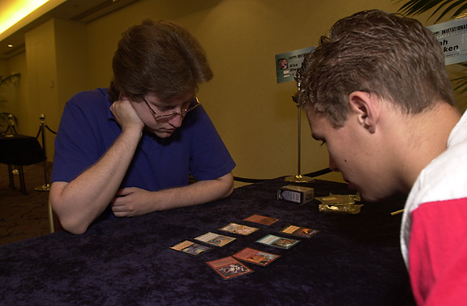
I watched Alex Shvartsman, my pick to stun everyone and make the finals, battle immediately to the top of the standings, only to get smashed back down when he found out that you can't get a lead and then draw your way in. David Price picked up where Alex left off with an inspired performance that would leave him battling for one of the top two spots all the way through the last round with his Mishra's Workshop-driven Type I artifact deck. I talked to Zvi when he sat alone in his room in frustration as he battled frantically but to no avail not to avoid last place.
As for myself, I'll fast forward to the last round of the tournament, when I played Finkel. I'll start off by saying I should have knocked on wood when I told Trevor that I had never played in garbage time at the Invitational, because by the third day I could have won all of my matches and still watched the finals from the cheap seats. From there I learned that at the Invitational there is no garbage time, as in my last three matches, with no chance for glory, I faced Bob Maher for a close win and Kai Budde for an embarrassing loss.
My last match, though, was important. I was trying to deny Finkel his second shot at the title. If he lost to me with the same deck as Maher that I had beaten the round before, he might well have lost another opportunity. Type I was kind of my thing, especially control on control, as both Jon and I played Keeper-style decks similar to the one I played in the finals of the very first Invitational in Hong Kong, where I lost to Olle Rade. At least I could show my A game.
So Finkel and I played, two of the better players our game has seen. We've faced one another a half dozen times before with about equal results. I'll do my name the service of saying that we both played hard and Jon walked away with the win, though I might have felt sure that day the he was the best player the game had ever seen. And I also thought that I had seen better days. That I had faced down Finkel, Rade, Place, Weissman and Pikula in my past. I might have thought that I made the best of my chances. And I might have thought of how cool the Invitational is. Fifteen matches without a penny to show for it, as we go into the age of Master's play, where five wins can net you $25,000.00. I look forward to watching the next generation seize their opportunities at the Invitational. I want to see Finkel struggle to maintain his hold on the game as he faces Zvi, and Budde. As he takes on new stars like Chris Benefel and Tsuyoshi Fujita, and Ben Rubin. I'll be downloading net results from South Africa to see who's next.

